**Re Assure API Internal Testing(Create Claim)**  
 **31/03/2020**

1. User is able to post the API by entering invalid data in Start date, End Date field, Loss_date, claim_creation_date, earliest_start_permitted, due_date and expected_datetime_closure  
   01/01/12-DD/MM/YYYY  
   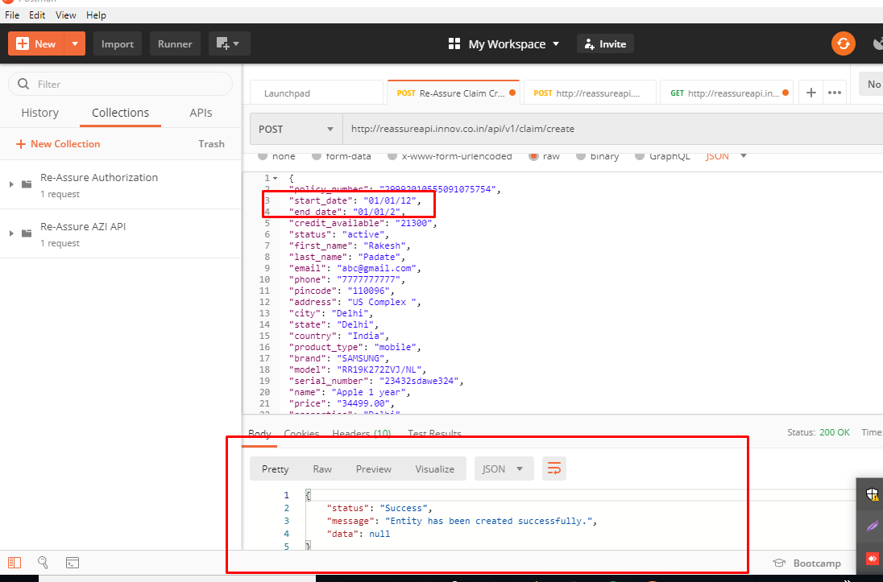
2. User is able to post the API by entering invalid data (Alphanumeric data) in Phone number field   
     
   . It should only take numbers.  
     
   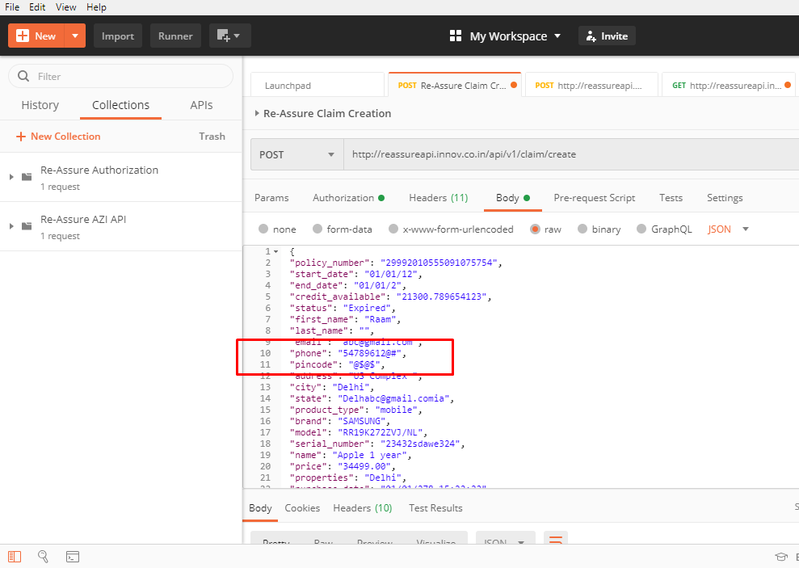  
     
     
   3)User is able to post the API by entering invalid data (Alphanumeric data) in Pin Codefield   
     
   . It should only take numbers.  
   

4) There should be a validation message for Leaving Loss Date field blank.  
  
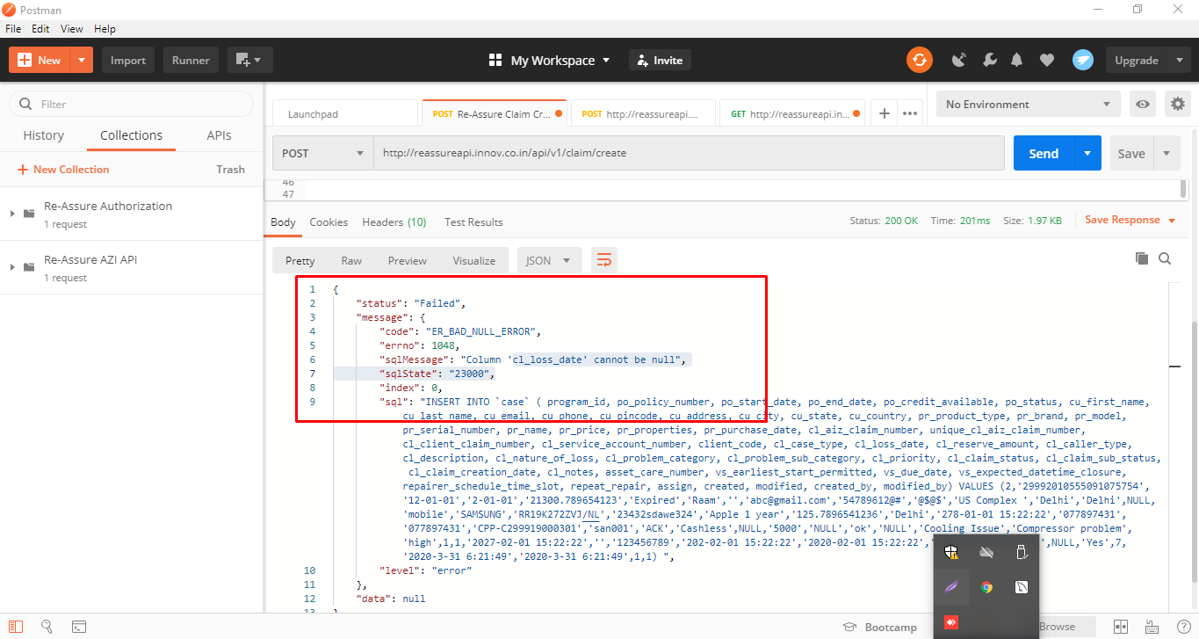

5) Please remove the validation for Priority as it's not a mandatory field and it can be left blank.  
  
{

"status": "Failed",

"message": {

"code": "ER_BAD_NULL_ERROR",

"errno": 1048,

"sqlMessage": "Column 'cl_priority' cannot be null",

"sqlState": "23000",

6) There should be a validation message for Leaving

Reserve Amount field blank.  
  
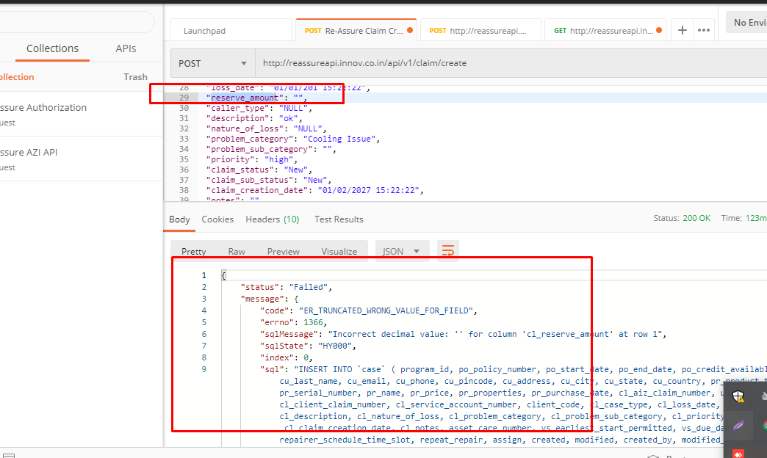  
  
7)There should be a validation message for Leaving

Claim Status field blank.  
  
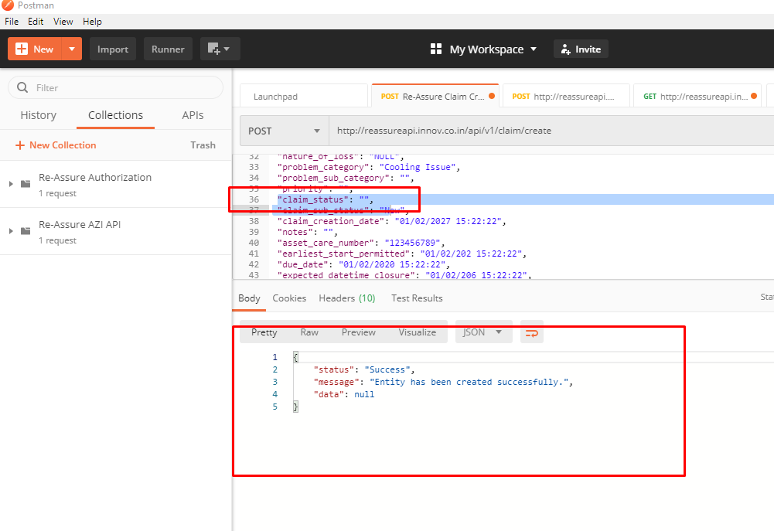

8)There should be a validation message for Leaving

Claim Sub Status field blank.  
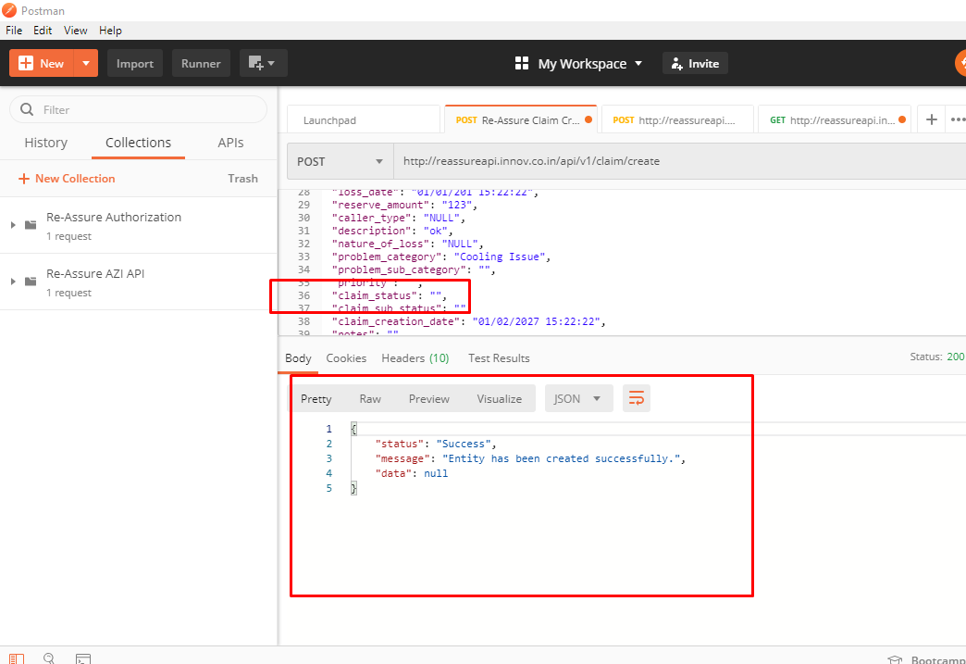  
  
9) There should be a proper validation message for entering invalid data in expected_datetime_closure field. It cannot take alphabets and special characters.  
  
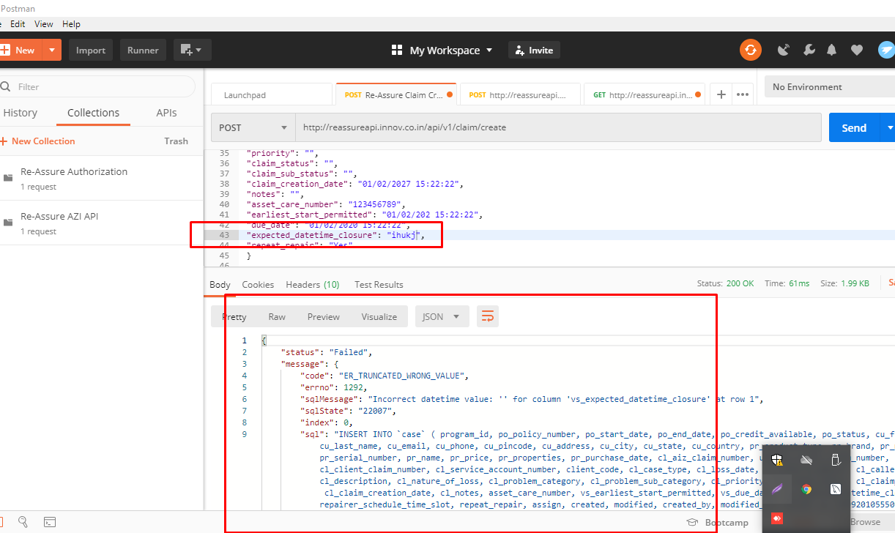

PayLoad:

{

"policy_number": "29992010555091075754",

"start_date": "01/01/12",

"end_date": "01/01/2",

"credit_available": "21300.789654123",

"status": "Expired",

"first_name": "Raam",

"last_name": "",

"email": "abc@gmail.com",

"phone": "54789612@#",

"pincode": "@$@$",

"address": "US Complex ",

"city": "Delhi",

"state": "Delhi",

"product_type": "mobile",

"brand": "SAMSUNG",

"model": "RR19K272ZVJ/NL",

"serial_number": "23432sdawe324",

"name": "Apple 1 year",

"price": "125.7896541236",

"properties": "Delhi",

"purchase_date": "01/01/278 15:22:22",

"aiz_claim_number": "0778973147",

"client_claim_number": "CPP-C299919000301",

"service_account_number": "san001",

"client_code": "ACK",

"case_type": "Cashless",

"loss_date": "01/01/201 15:22:22",

"reserve_amount": "123",

"caller_type": "NULL",

"description": "ok",

"nature_of_loss": "NULL",

"problem_category": "Cooling Issue",

"problem_sub_category": "",

"priority": "",

"claim_status": "",

"claim_sub_status": "",

"claim_creation_date": "01/02/2027 15:22:22",

"notes": "",

"asset_care_number": "123456789",

"earliest_start_permitted": "01/02/202 15:22:22",

"due_date": "01/02/2020 15:22:22",

"expected_datetime_closure": "",

"repeat_repair": "Yes"

}

**Re Assure API Internal Testing   
30/03/2020**

1)error coming on leaving start_date empty while creating a claim.-Fixed 31/03/2020

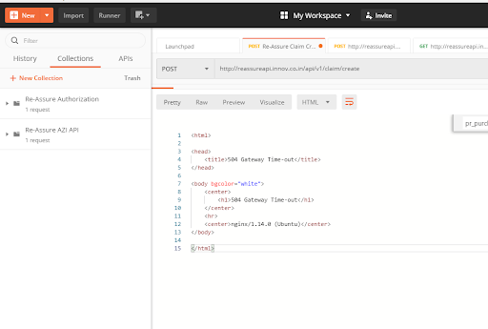

2) Error is coming for leaving End Date blank while creating claim. Fixed 31/03/2020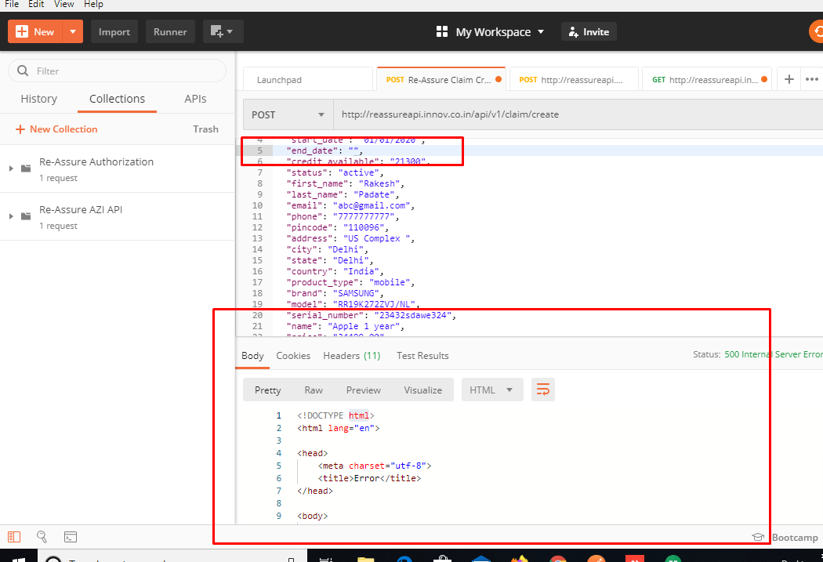  
  
3)Validation message for entering invalid Date in start date is not coming. Fixed 31/03/2020

4) Status field can only take Active/Cancelled/Expired else remove the character limit from it.-Deferred 31/03/2020

5) For all the fields having Data types as Date-Time (purchase_date,loss_date,claim_creation_date,Earliest_start_permitted,expected_datetime_closure and due_date , If user )enters valid date time then error gets appear as below screenshot. - Fixed 31/03/2020  
  
  
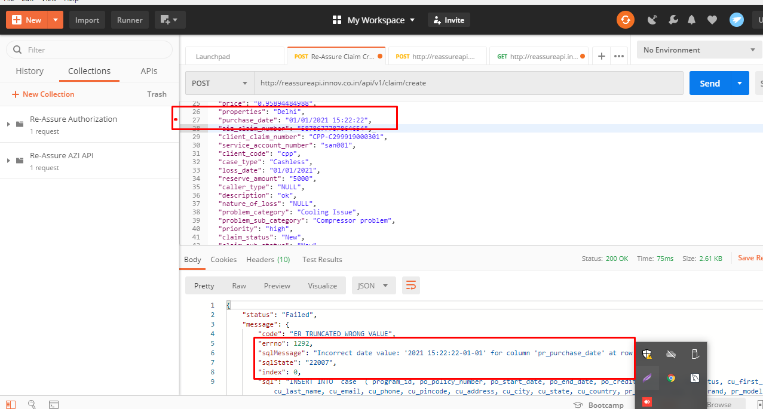

6) User is able to create claim by entering alphanumeric valium in AIZ claim number as per the API integration Document It can only take numbers . Fixed 31/03/2020  
  
  
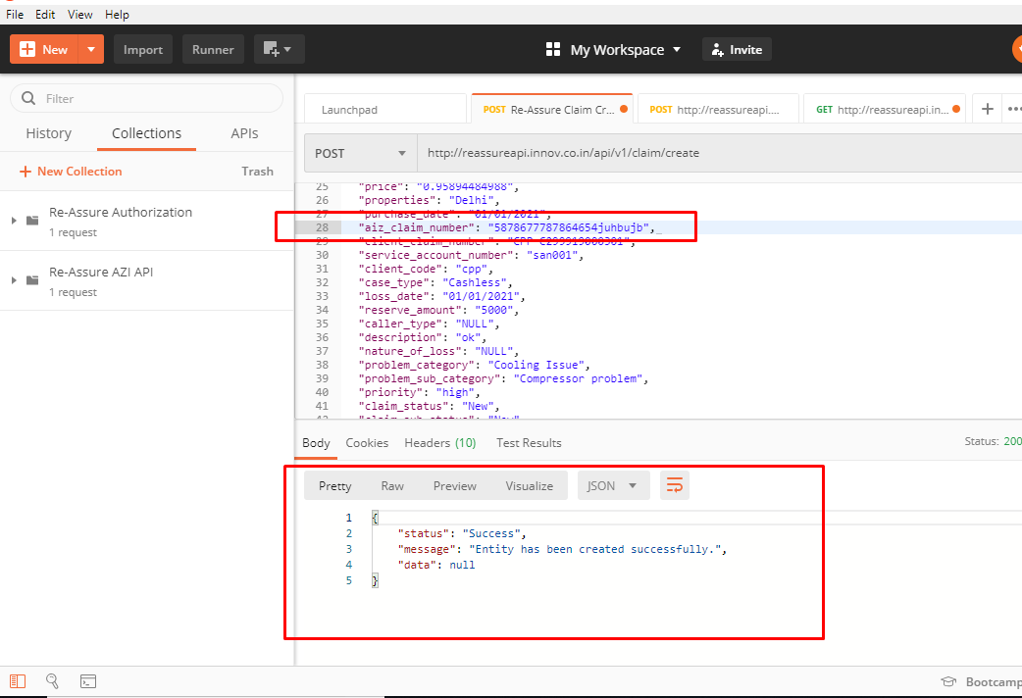

7) There is no validation appears for leaving Claim Status field blank. There should be a validation message for leaving it blank as its a mandatory field.

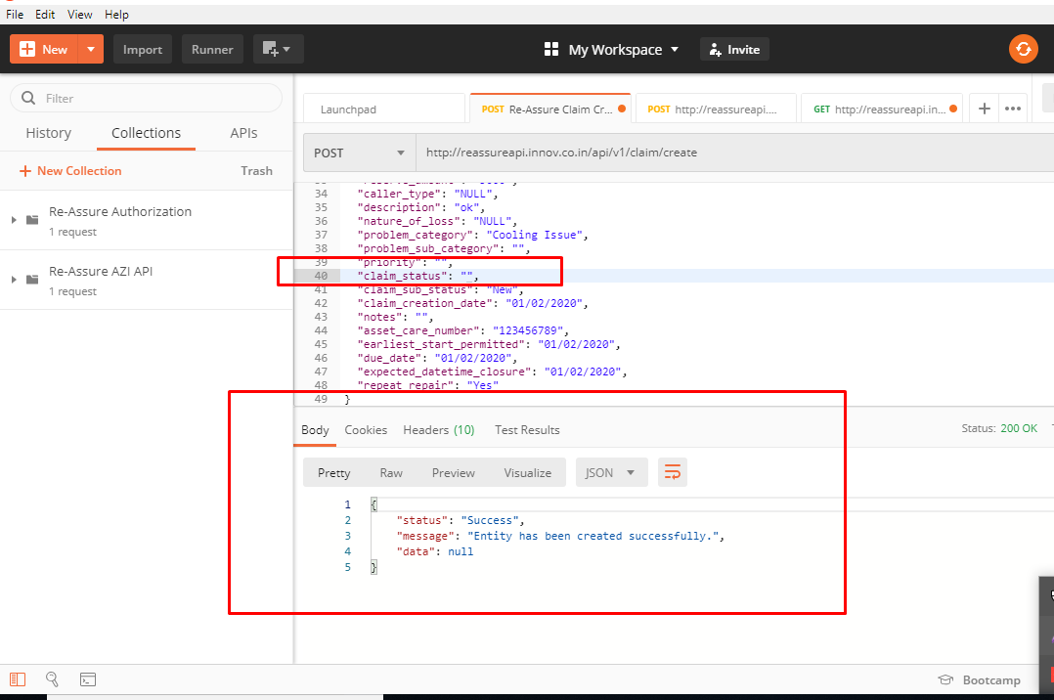

8) There is no validation appears for leaving

Claim Sub Status field blank. There should be a validation message for leaving it blank as its a mandatory field.

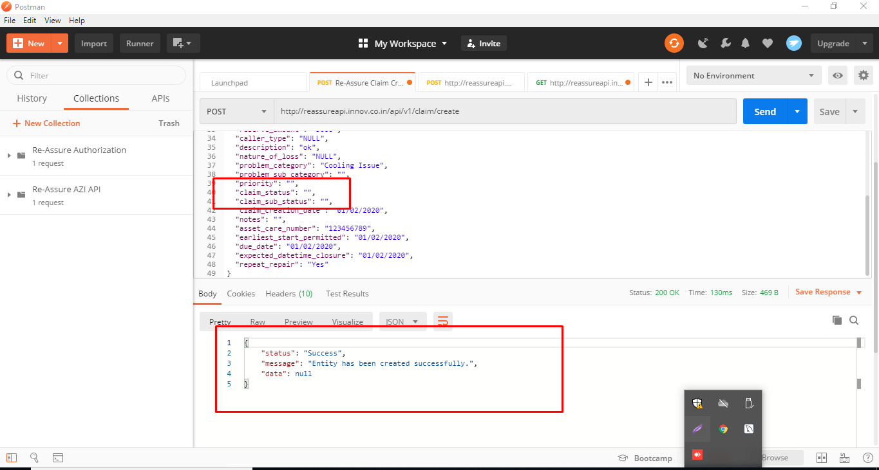

9) For leaving Claim creation date blank following error is coming please find below:  
504 Gateway Time-out --Fixed 31/03/2020

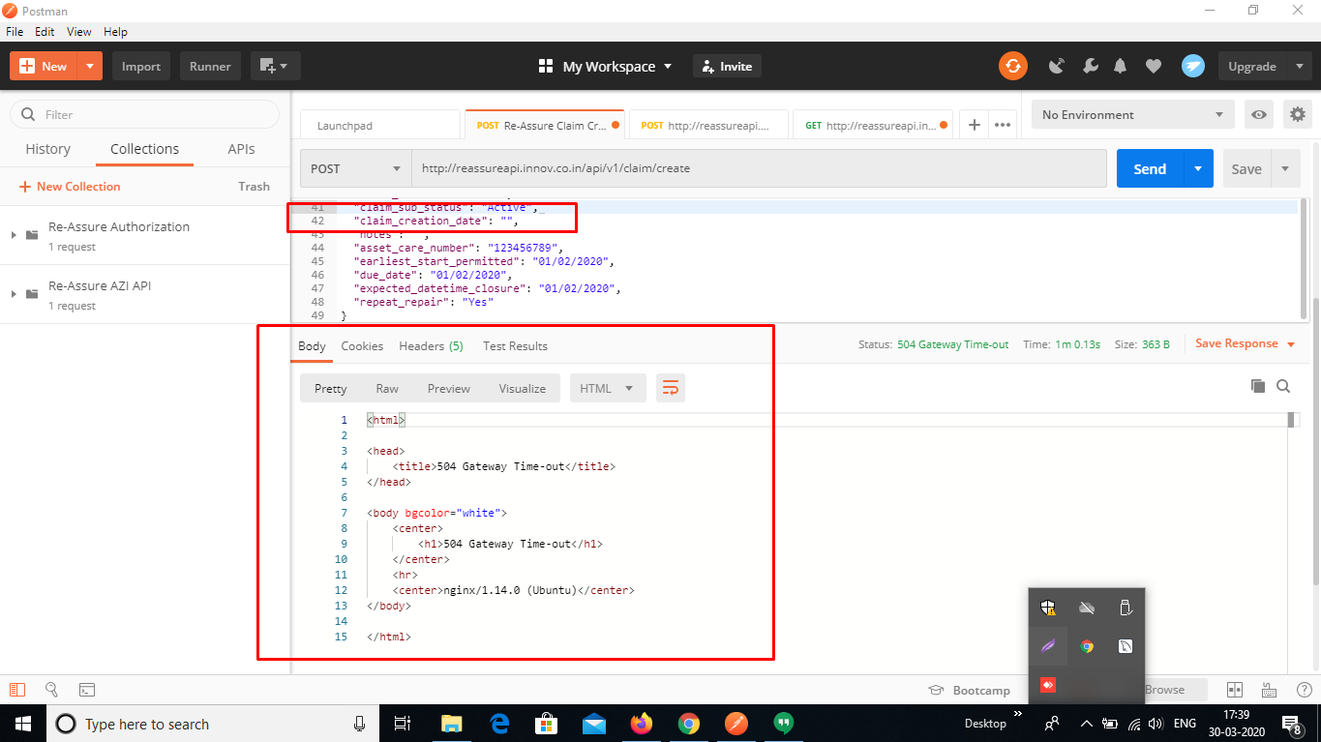

10)There is no validation appears for leaving

Earliest Start Permitted date field blank. There should be a validation message for leaving it blank as its a mandatory field. Fixed 31/03/2020

